Setup
How to copy the GLP or MFP link to your templates
Here is the GLP/MFP link:
Click here

How to copy the GLP or MFP link to your templates:
- Highlight the link above:
- Click on Ctrl C to copy the link
- Go to the spot where you want it on the template you are copying to
- Click on Ctrl V to paste link there
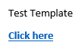
- To test the link:
  - Hold the Alt key and press the F9 key
  - If everything is correct, it should look like below:
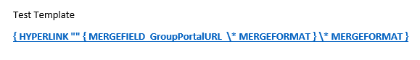
- If you want to change the text of the link:
  - Let’s say the desired text is “Go to the Online Link”
  - Click before the last ‘e’ in here and delete up to the ‘C’ in click
  - Then enter the desired text after the ‘C’
  - Click after the ‘C’ and backspace to delete it
  - Click before the last ‘e’ and hit the delete key to delete forward
  - Hint:
    - Ctrl Z will undo the last change, so if the link suddenly breaks you can sometimes bring it back via the undo function
- Save your Template document
- Is the template in Marketing Templates in My Fundraising Place?
  - No
    - Add to Marketing Templates
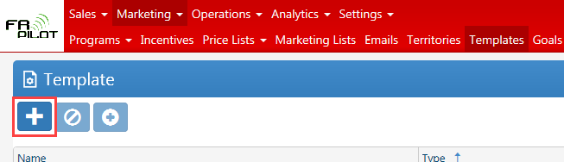
      - Enter in Name and Description
      - Make sure the correct Template Type is selected
      - Click on the Select Files button and select the template file
      - Click on the OK button
  - Yes
    - Upload the new template
      - Double-click on appropriate template
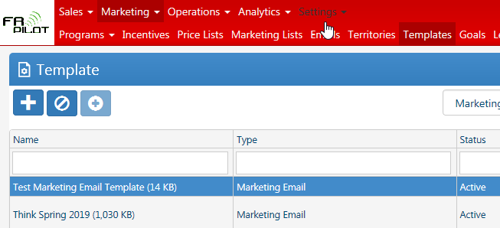
      - Click on the Select Files button and select the template file
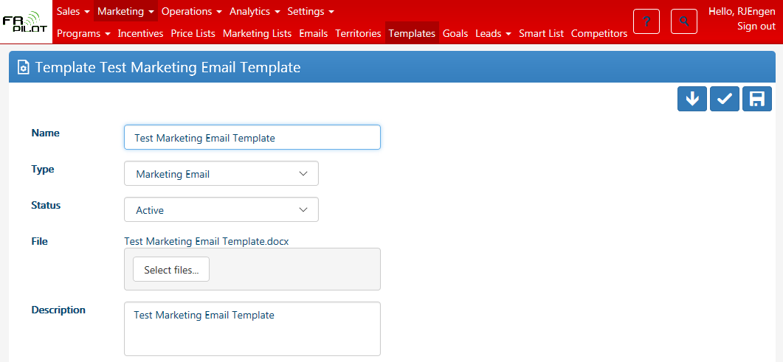
      - Click on the OK button
      - Click on the Save & Close button
- My Fundraising Place Testing
  - Touchpoint documents
    - Order Reminder & Midpoint typically are used with this link, possibly more
    - If the Touchpoint Template is not associated with the correct Marketing Program:
      - Click on the Edit Touchpoints button
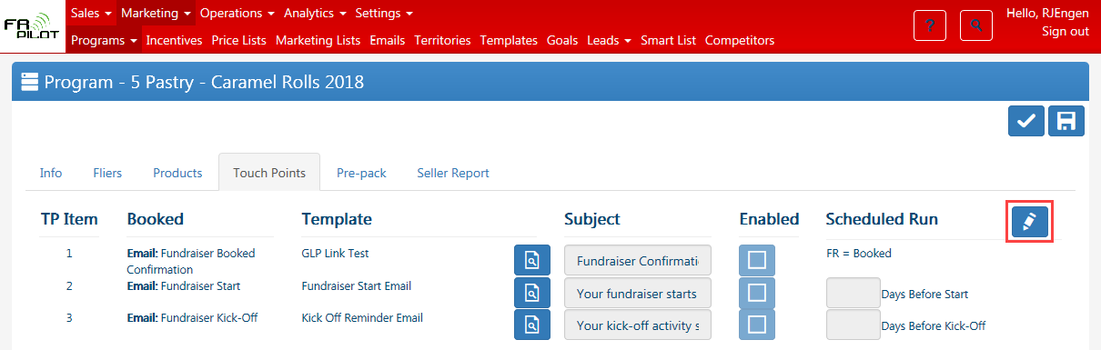
      - Click on Delete Template from Program button
      - Click on Add New Template to Program button and select appropriate template
      - 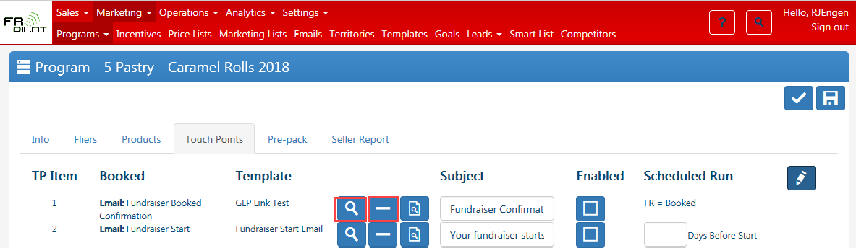
      - Click on Save & Close button
    - Test Touchpoint Template
      - Go to Sales > Fundraisers > Touch Points Tab
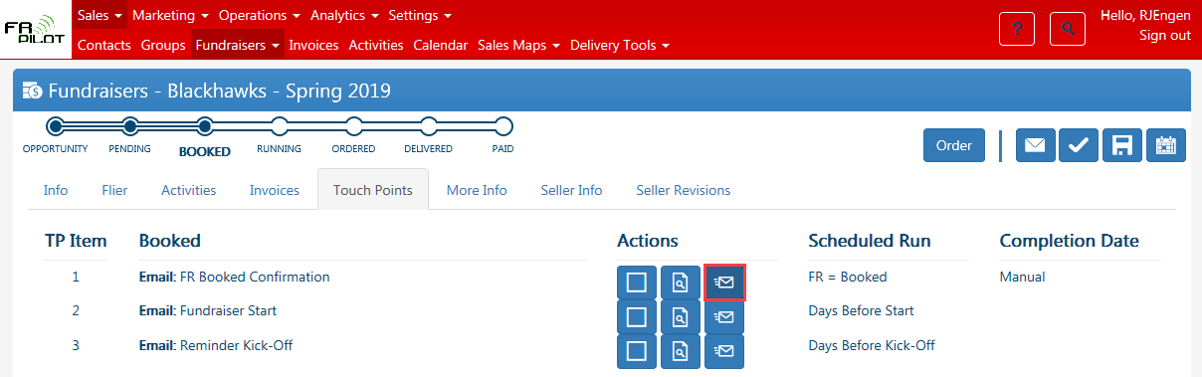
      - Click on the Resend button for the appropriate Touch Point
      - Remove the email address in the email – to eliminate the chance of accidentally sending
      - Click on the Link in the email to verify that it is working
      - Note: The Preview button that creates a Word Document does not work to test the link

